A1a. $ρ$ (C_iphonecid(pname=’iPhone’(Product $⋈$ Buy))))

$ρ$ (C_ipadcid(pname=’iPad’(Product $⋈$ Buy))))

$π_{cname}$ (($C_{ipone}∩C_ipad$) $⋈Customer)$

A1b. $ρ(BobList,π_{cname=^{'}Bob^{'}} (\left(Product⋈Buy\right)⋈Customer)$

$$ρ(p1,π_price(BobList)$$

$$ρ(p2,π_price(BobList)$$

$$ρ(inter_price(1→low,2→high),p1⋈_{p1.price<p2.price}p2)$$

$$π_{pid}(BobList-BobList⋈π_{low}(inter_price))$$

A2a. $$ρ(origin_set\left(1→sid1,2→cid1,3→sid2,4→cid2\right),\left(Enroll×Enroll\right))$$

$$ρ(inter_set,π_{sid1,sid2,cid1}(σ_{cid1=cid2}\left(σ_{sid1!=sid2}\left(origin_{set}\right)\right)))$$

$$ρ(stu_pair,π_{sid1,sid2}(inter_set))$$

$$ρ(temp\left(3→sid3\right),stu_{pair}×Enroll)$$

$$ρ(temp1,π_{sid1,sid2,cid}(σ_{sid1=sid3}\left(temp\right)))$$

$$ρ(temp2,π_{sid1,sid2,cid}(σ_{sid2=sid3}\left(temp\right)))$$

$$ρ(fullset,temp1∪temp2)$$

$$ρ(disqualified,π_{sid1,sid2}\left(fullset-inter_set\right))$$

$$ρ(answer,stu_set-disqualified)$$

A2b. $ρ(inter_sect\left(1→sid1,2→method1,3→sid2,,4→method2\right),π_{sid,method}\left(onestop\right)×π_{sid, method}(onestop))$

$$ρ(individual_sect,π_{sid1,method1,method2}\left({σ_{method1!=method2}(σ}_{sid1=sid2}\left(inter_{sect}\right)\right)))$$

$$ρ(individual_sect\left(1→sid\right),individual_sect)$$

$$ρ(temp\left(4→method3\right),individual_sect⋈_{sid}π_{sid,method}(onestop))$$

$$ρ(t1,π_{sid}(σ_{method2!=method3}(temp)))$$

$$ρ(t2,π_{sid}(σ_{method1!=method3}(temp)))$$

$$ρ(morethan2,t1∩t2)$$

$$ρ(answer,π_{sid}\left(individual_{sect}\right)-moretahn2)$$

A3. $ρ(Serve_Table,\left(π_{dId,barId}\left(Drinkers⋈_{did}Frequents\right)\right)⋈_{barId}Serves)$

$$ρ(Serve_Table\left(3→ServeBeer\right),Serve_Table)$$

$$ρ(Compare_Table\left(4→LikeBeer\right),Serve_Table⋈_{dId} Likes)$$

$$ρ(fit_table,σ_{dId,barId}(π_{ServeBeer=LikeBeer}Compare_Tabel))$$

$$ρ(Answer,σ_{dId}Drinkers-σ_{dId}(Likes-fit_table))$$

Part B

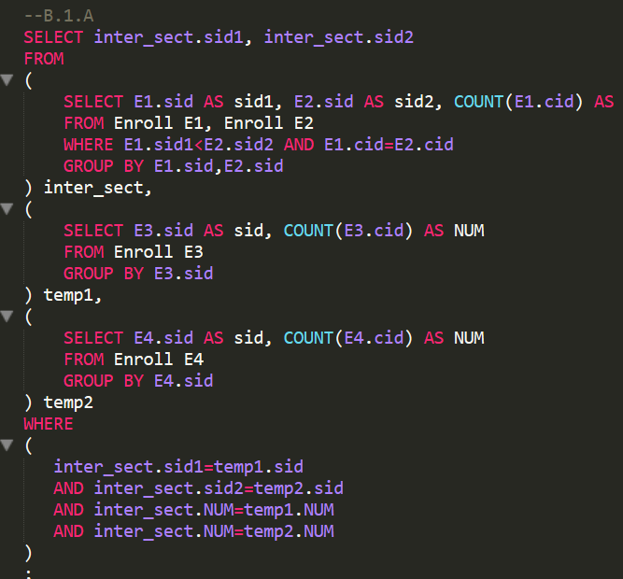

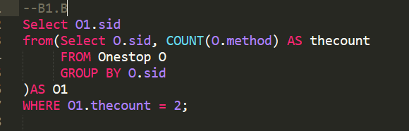

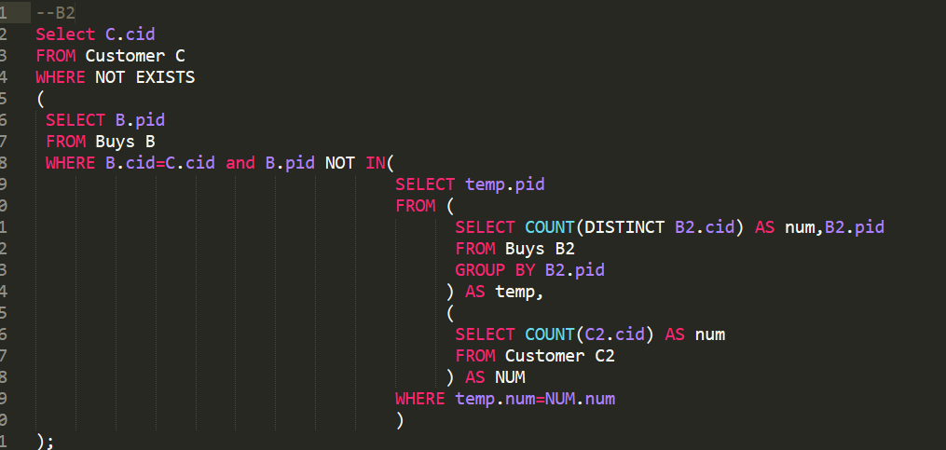

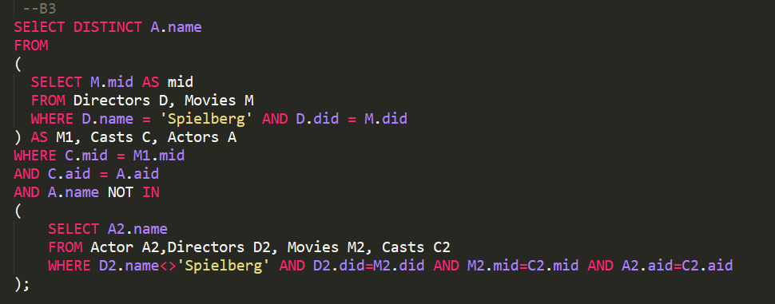

PartC:

1. a

MRU

For the most of time file is sequentially scanned, under such condition ,we could conclude that the buffer which is recently accessed would be less probably accessed again. However, FIFO will not delete the buffer which is less probably accessed. LRU will delete least recently accessed buffer which is most probably accessed again. So the MRU is the best choice under such condition

2.b

LRU

Obviously under such condition LRU is the most suitable policy because items which are frequently requested should be kept in the buffer to avoid wasting time in reloading them from disk to the buffer . LRU could satisfy this requirement. However, MRU and FIFO will cause the waste of time in loading the frequently requested items. So the LRU is the best choice